
Name: Abdul Samad
Program: BSSE Group A
Semester: 5th
Date: October 16, 2026
*-----------------------------------------------*

Lab Task 7
Point to Point Topology:

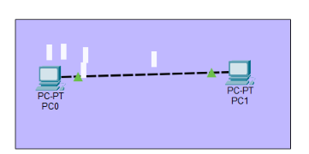

Bus Topology:

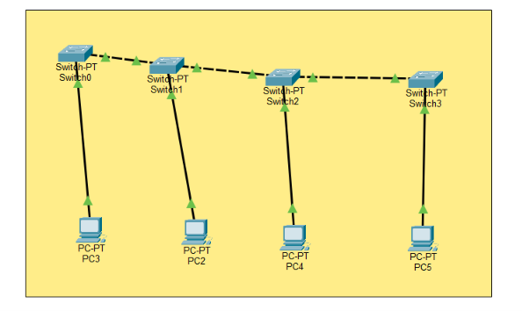

Star Topology:

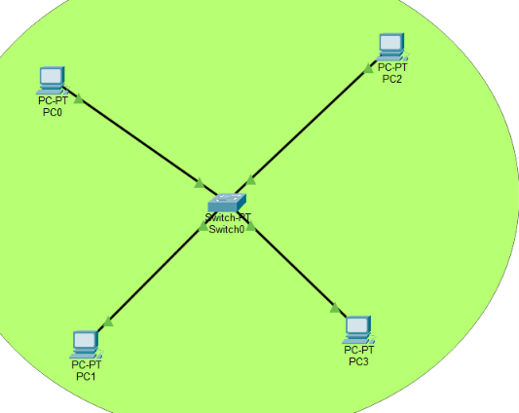

Ring Topology:

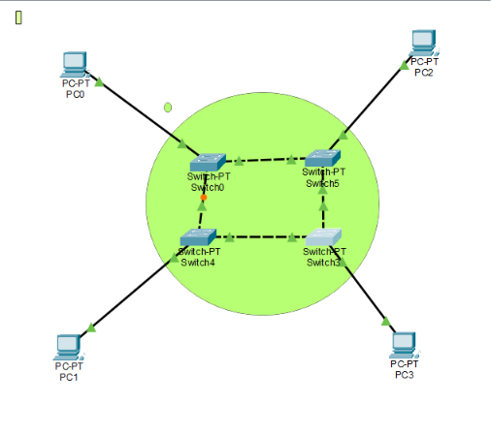
Mesh Topology:
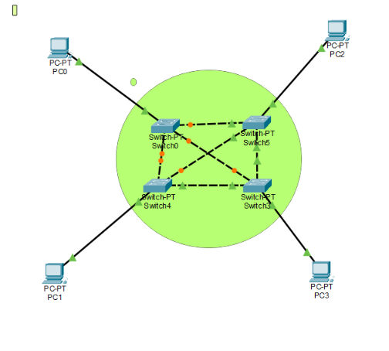
*-----------------------------------------------*

The End

